# Assignment of Statistical Learning

This relation is going to report my findings for this assignment.

## Assignment 1

In this assignment I try to predict the number of comments our Facebook posts will get.

For this tasked I used two algorithms and I took the best result I got from the two.

The result is that every Facebook post should get 7 comments which is will more correct than the other method, given what we observed with the training set, that sets the comments between a minimum 2 of and a maximum of 7999 comments.

To get better results i should probably do some more operations on the data and try some other algorithms.

However, I would have needed more time and study to do so.

## Assignment 2

In this assignment I analyze, with the help of the recursive partitioning technique, how many spam messages we may get using what has been recorded in the passing periods.

As we can see, these are the most common terms we can find in spam messages:

* 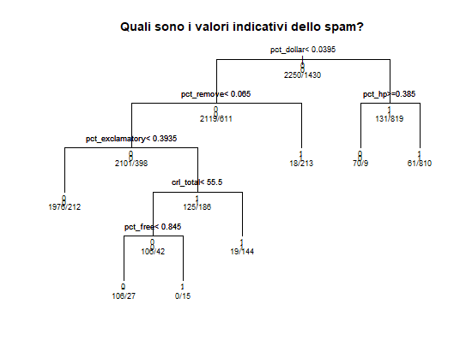Dollar
* Remove
* Exclamatory (sign)
* hp

This method brings to these results:

On 921 test messages, 372 were classified as spam and 549 resulted in normal emails.

This method is in line with what was previously found in the training set used to compose the model.

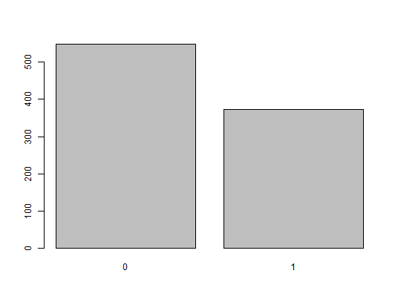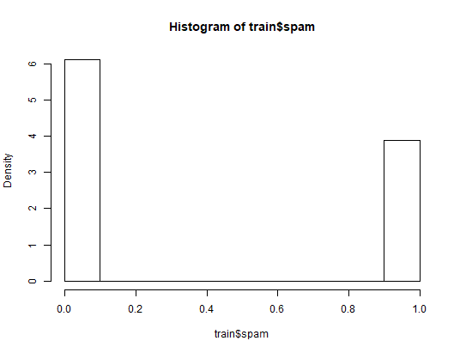

Figure 2Relative % of spam messages we observed

Figure 1Results of the model